|  |
| --- |
| BIXI Analytics Report  BIXI DELIVERABLE Pt. 2 |
| BIXI Street Address  City, ST ZIP Code  Phone  Email |



## Company Name Marketing Plan

### **BI Manager**

Recall the membership numbers in both 2016 and 2017.

### 

We notice that there are more users in the summer in both years, but in the year 2017 the difference between the summer and the rest of the year is much greater. There are also many more users in the year 2017. We also have seen a slight increase in membership usage:

### 

### Compared to 2016, 2017 saw a slight increased usage during the summer, particularly after June. The 2017 summer (June, July, august and September) made up 68% compared to 66.9% in 2016

### **Marketing Team**

The marketing team is primarily interested in the types of trips users are making, particularily those who . In response, the top 10 stations who has the largest amount of roundtrips is shown below:

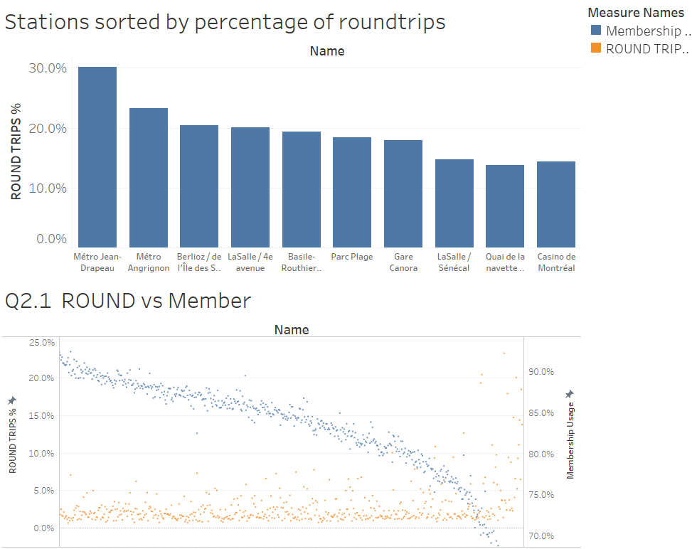

The marketing team is encouraged to visit dashboard 2 for a detailed look at both this graph and an interactive graph of % of round trips vs % of members. One valuable insight gained from these graphs is the lower the membership percentage, the higher the round trip usage. This relationship isn’t too defined but it is apparent nevertheless. The y-axes have been adjusted to better portray this relationship.

There is also the matter of the length of each trip. Here is the graph of usage among members and none-members:

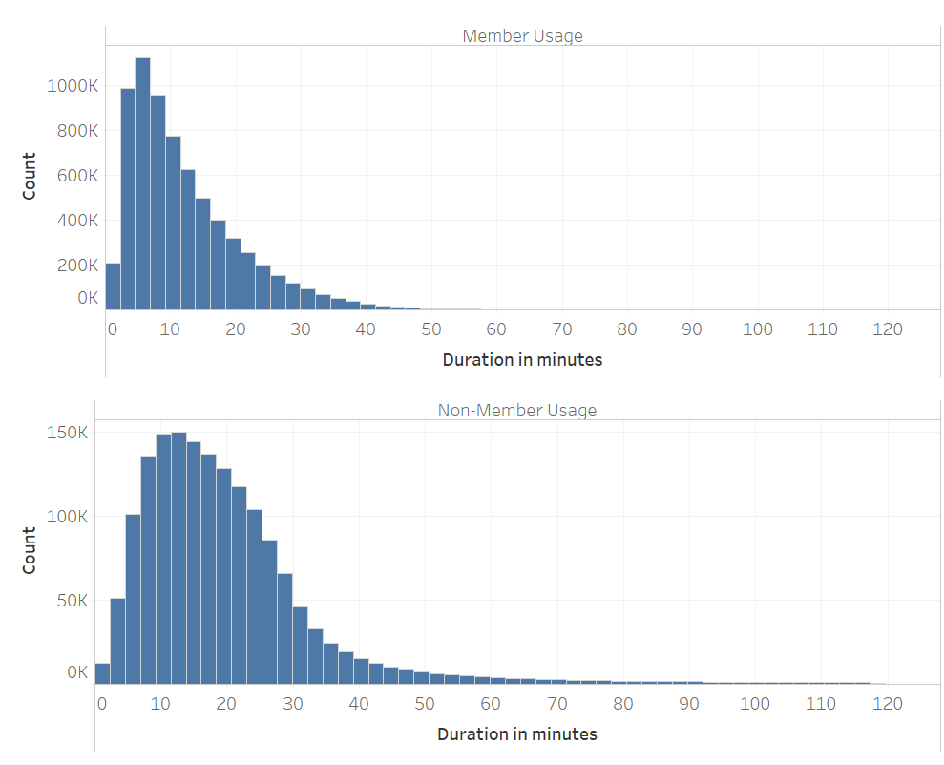

Members tend to take shorter trips than non-members. Most members take trips that last 2-7 minutes, while the majority of non-members take trips that last 9-18 minutes. This may be due to the privileges members have in terms of fees for using the bike, allowing for shorter trips at no additional cost, while non-members want to make the most of their ride. One can gain further insight to the question of “How long does one use BIXI?” by also asking “Where does one use BIXI?”:

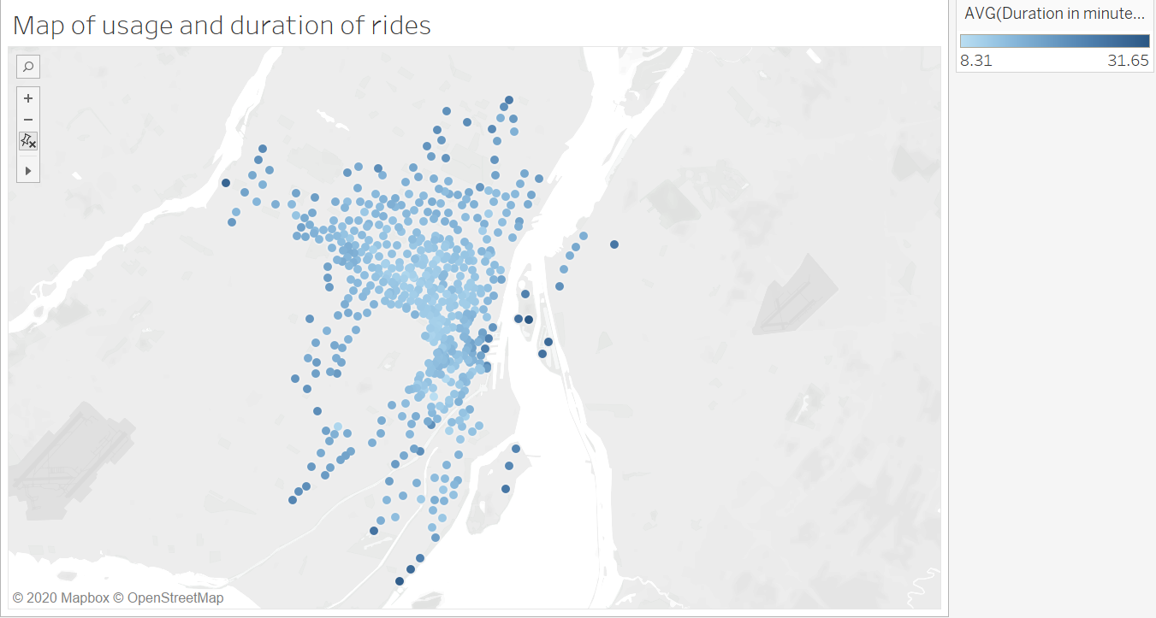

### We can see 2 trend emerge from this map:

### In general, areas with stations clustered closer together see lower trip durations.

### stations near bodies of water see higher trip durations

### The 1st trend emerges as a result of convenience. Closer stations mean users can pick up and drop off the bikes at their leisure. Such ease means users may use it as an alternative to walking whenever they see fit.  Farther stations may require more biking to get to, thus longer duration.

### The second can be explained by tourism, these areas are quite scenic, so users may be looking to enjoy the ride for longer and explore, see the sights more. This could also be explained by the first point, as in general (a few exceptions) stations near bodies of water are further apart

### As a quick point on financials:

|  |  |  |  |
| --- | --- | --- | --- |
|  | **Rides <30 Min** | **Rides 30-45 Min** | **Rides>45 Min** |
| **Revenue** | $23,944,655.54 | $2,150,403.44 | $1,096,689.45 |
| **Percentage of total** | 88% | 8% | 4% |

### However earlier today I had received a passive aggressive notice from the Director of Finance that my graphs were not “Detailed enough”, to which I say please refer to the graph below:

### 

### This is much better experienced when used in the interactive dashboard provided.